ZTW Spider Series 30A OPTO Brushless Speed Control ECS for Multicopter Qudcopter Airplane Part
ZTW Spider Series 30A OPTO Brushless Speed Control ESC 2-6S Lipo for DJI Flame Wheel F450 F550

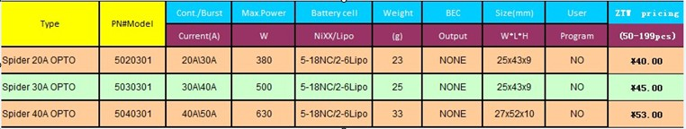

Features:
Continuous Output: 30A
Burst Output: 40A
Max. Power: 500W
Battery: 5-18NC/2-6Lip
Length: 43mm
Width: 25mm
Height: 10mm
Weight: 26g
Supports high RPM motors
Extremely low internal resistance
Super smooth and accurate throttle linearity
Safety thermal over-load protection
Auto throttle shut down in signal loss situation
Power arming protection (prevents the motor from accidentally running when switched ON)
Use new generation of the MOSFETs ensuring low heating and more reliability operation

Package Include:
1 x ZTW Spider 30A ESC

